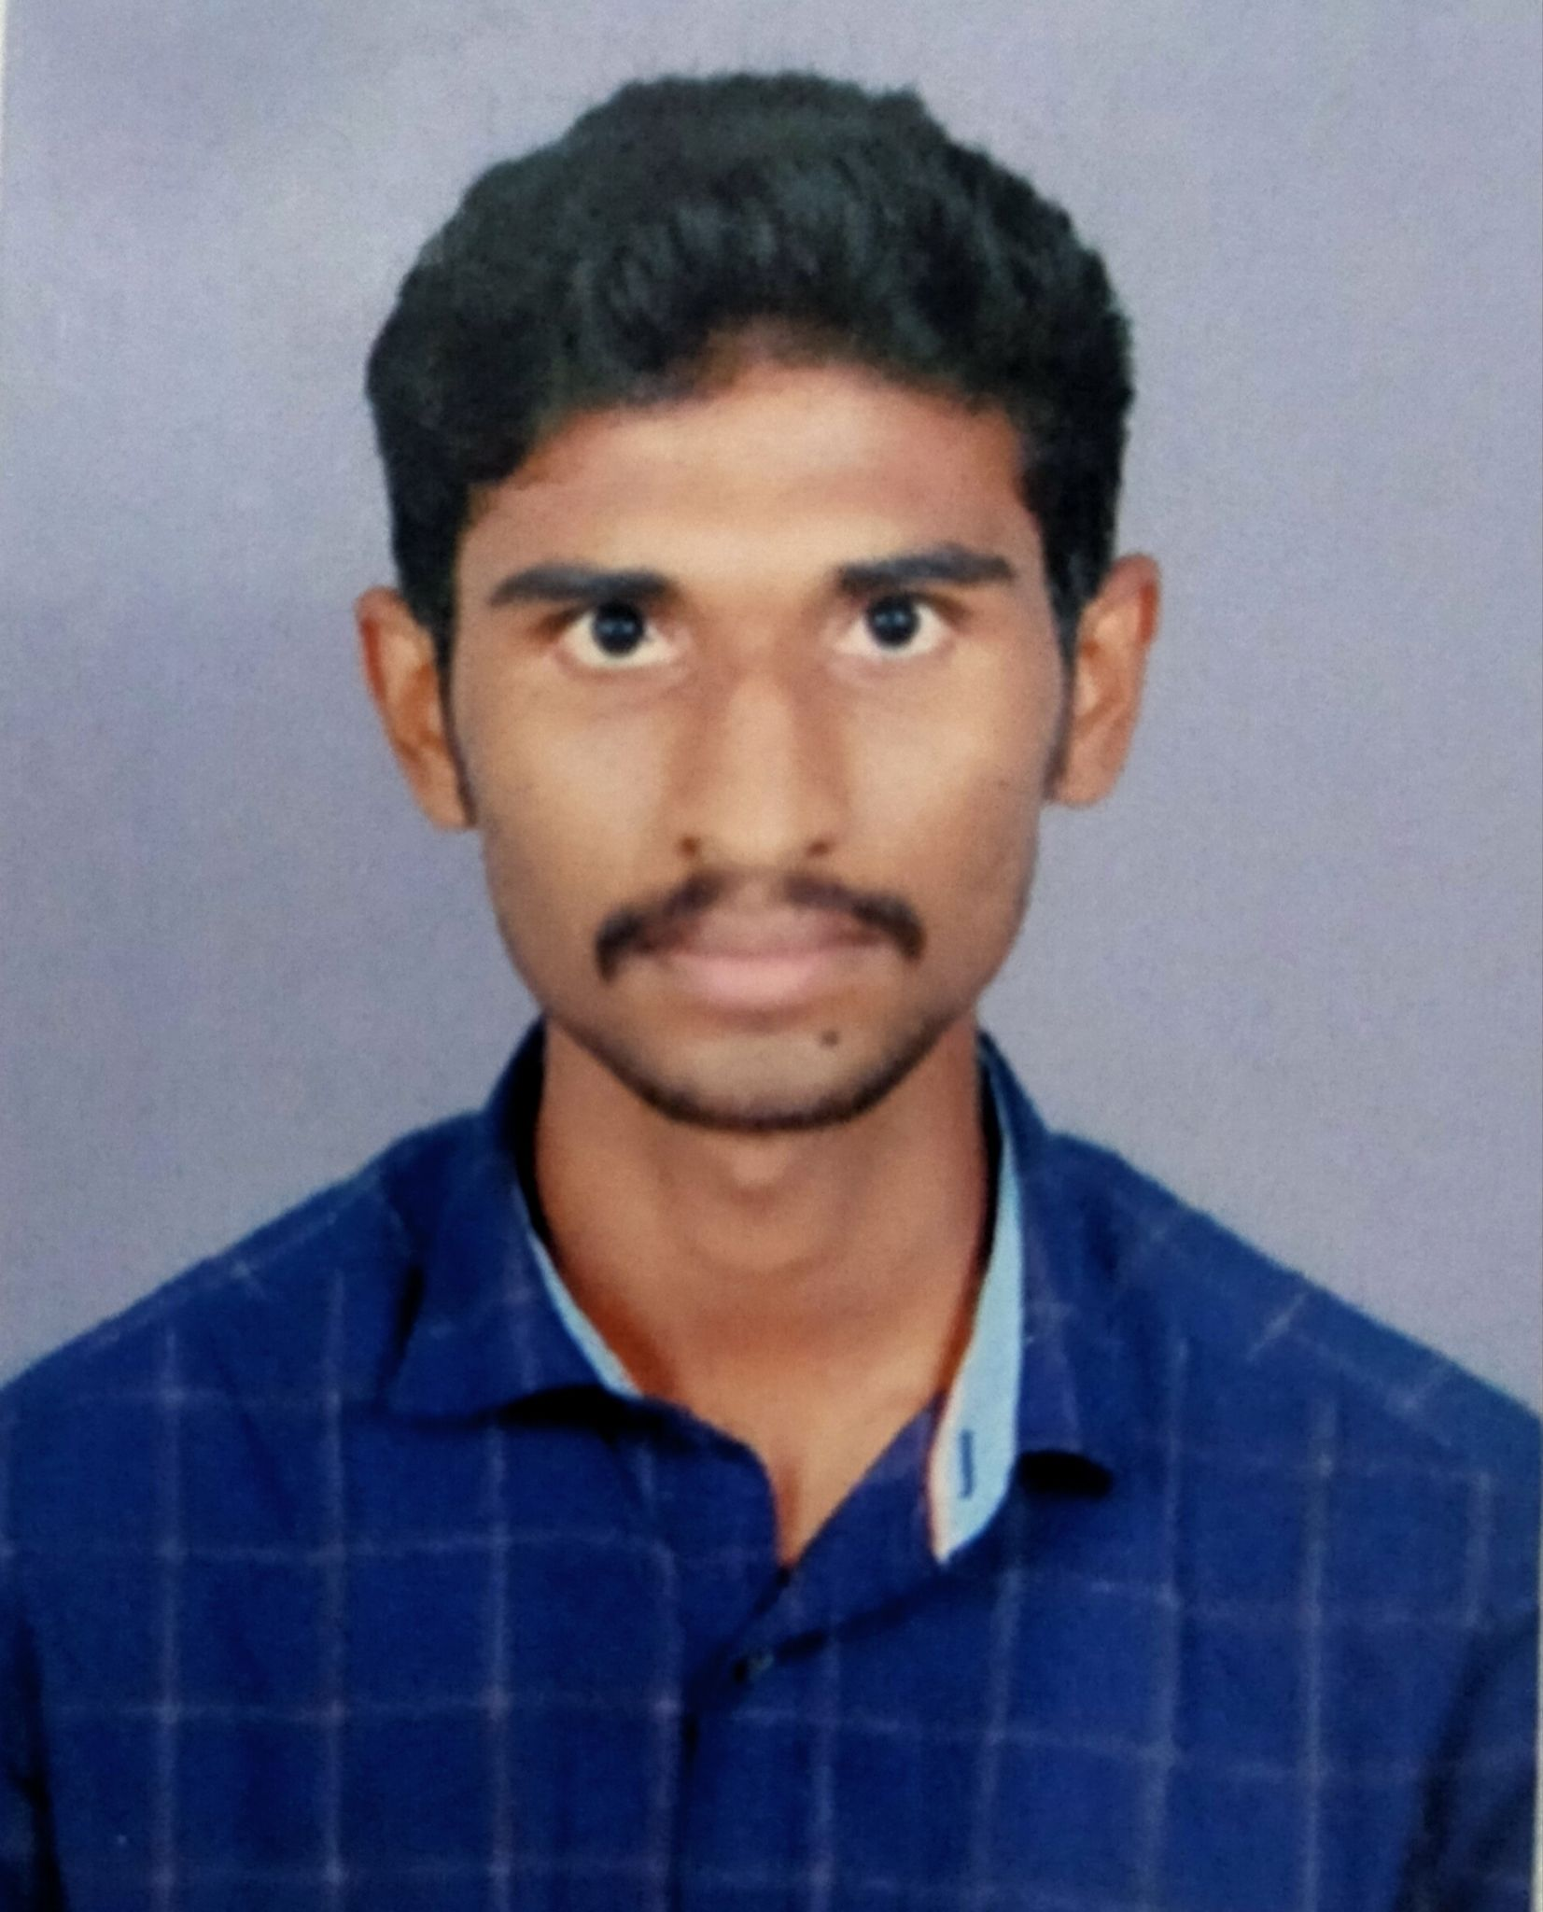

**DHANAJAYAN K**

**SALEM,India,**

**Email:** [**dhanajayan99@gmail.com**](mailto:dhanajayan99@gmail.com)

**Mob: +91 82209 26833**

# PROFESSIONAL SUMMARY:

# Experienced in Java and Mainframe Enhancement with 1+ years of experience in the IT industry. Excellent reputation for resolving problems and improving client satisfaction.

**SKILLS:**

* COBOL
* Java
* JCL
* VSAM
* DB2
* Endevor
* CA7 Scheduler
* Autosys

**WORK HISTORY:**

**COGNIZANT TECHNOLOGY SOLUTIONS | Chennai : 30/07/2021 to 02/09/2022**

# Roles and responsibilities as Mainframe Support Engineer:

* Working for the client Lincoln Financial Group (LFG) in an Insurance Domain
* Leading a team of 6 members involved production support and enhancement.
* Cobol code enhancement as per user requirement and giving fixes for issues reported
* Job monitoring during month end and giving support for production cycle
* Daily Abend fix in order ensure smooth running of production cycles.
* Running SQL queries for database testing using SQL Server Management Studio.
* Moving Code changes with Change Management Tool Endeavor
* Using File-AID for files processing
* Requirement gathering, analyzing and code change/add for multiple scenarios.
* Providing reports on issues and progress to the stakeholders.
* Autosys job setup.
* working to develop CA7 to monitor jobs

# Project Details:

* Title :Life and Annuity
* Domain : Insurance
* Type : Enhancement and Support
* Skills : Cobol,JCL and Autosys
* Role : Programmer

**Objective:**

To provide Daily, Weekly and Monthly support to the production cycles which sends statements, letters and reports to the customers and agents. Involve in Enhancement of functionality as per user requirement.

**EDUCATIONAL QUALIFICATION:**

| **Degree/**  **Examination** | **Board/University** | **Year of passing** | **Percentage (%)** |
| --- | --- | --- | --- |
| M.C.A | Periyar University, Salem. | 2024 | 72.30 up to second semester |
| B.Sc. Computer Science | Periyar University Salem. | 2020 | 73.32 |
| HSC | State Board | 2017 | 52.58 |
| SSLC | State Board | 2015 | 76.80 |

Thanking you,

Yours Sincerely,

Date:

Place: Salem, India.

[DHANAJAYAN K]